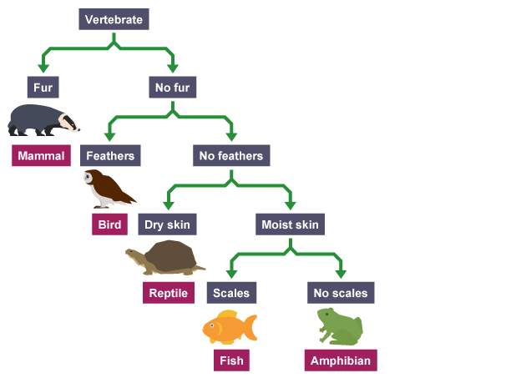
Year 7 Classification Test Revision – Answers

- Look at the dichotomous key for Vertebrates.
  - What features are used to separate the organisms?
    - Whether or not they have fur
    - Whether or not they have feathers
    - Whether their skin is dry or moist
    - Whether or not they have scales
  - What features does a bird have?
    - Feathers; no fur; a backbone
  - What features does a fish have?
    - Scales; moist skin; no feathers; no fur; a backbone

- Draw a branched dichotomous key for these animals.

- Rabbit
- Dog
- Cat
- Fish
- Guinea pig
- Bird
- Mouse
- Horse

  - (Answers will vary.)
- Write a tabular key for the branched key you drew in question 2.

  - (Answers will vary.)

- What are the three kingdoms of living things we have learnt about? Name two common features of organisms in each group.
  - Plants (producers; have cell walls)
  - Fungi (not producers; have cell walls)
  - Animals (not producers; no cell walls)

- Redraw, extend and complete the table to show the nine phyla we have learnt about in Kingdom Animalia.
Phylum | Characteristics | Example
Chordates | Have a spinal cord and backbone. | Monkey
Arthropods | Have an exoskeleton, jointed legs, and segmented bodies | (various)
Molluscs | Have soft bodies and often a protective shell
Nematodes | Worms with long, round bodies
Platyhelminths | Worms with flat or leaf-like bodies
Annelids | Worms with segmented bodies
Sponges | Have spongy bodies with holes
Cnidarians | Have soft, hollow bodies and stinging tentacles
Echinoderms | Have rough, spiny skin and repeated body parts around a central body

- For each of the animals below, name its phylum and explain your choice.

  - Starfish: echinoderm
  - Monkey: vertebrate
  - Ant: arthropod
  - Pelican: vertebrate
  - Prawn: arthropod
  - Snail: mollusc
  - Squid: mollusc
  - Sea urchin: echinoderm
  - Tape worm: platyhelminth
  - Leech: annelid
  - Meerkat: vertebrate
  - Jellyfish: cnidarian

- Redraw, extend and complete the table to show the 5 classes of chordates.
Class | Characteristics | Example
mammal | Hair or fur; warm-blooded; produce milk; give birth to live young | (various)
bird | Feathers and scaly legs; warm-blooded; lay eggs with hard shells
reptile | Scaly skin; cold-blooded; most lay eggs; use lungs to breathe
amphibian | Soft, slimy skin; cold-blooded; lay soft eggs; gills when young → lungs when fully grown
fish | Scaly skin; usually cold-blooded; most have fins; use gills to breathe

- For each of the chordates below, name its class and explain your choice.

  - Turtle: reptile
  - Cow: mammal
  - Lizard: reptile
  - Duck: bird
  - Crocodile: reptile
  - Tree Frog: amphibian
  - Shark: fish
  - Magpie: bird
  - Cane toad: amphibian
  - Lion: mammal
  - Eagle: bird
  - Tuna: fish
  - Alligator: reptile
  - Moose: mammal
  - Echidna: mammal
  - Koala: mammal

- Redraw, extend and complete the table to show the 4 classes of arthropods.
Class | Characteristics | Example
insects | 3 pairs of legs, 3 body parts | (various)
arachnids | 4 pairs of legs, 2 body parts
crustaceans | 5 or more pairs of legs, 2 or 3 body parts
myriapods | Many pairs of legs; many segments / worm-like body

- For each of the arthropods below, name its class and explain your choice.

  - Dung beetle: insect
  - Spider: arachnid
  - Earwig: insect
  - Scorpion: arachnid
  - Wasp: insect
  - Lobster: crustacean
  - Millipede: myriapod
  - Crab: crustacean
  - Butterfly: insect
  - Fly: insect

